Wi-Fi fingerprint similarity in collaborative radio maps for indoor positioning

Diogo Matos, Adriano Moreira, Filipe Meneses

Algoritmi Research Center, University of Minho, Guimarães, Portugal [diogomatos.gmr@gmail.com,](mailto:diogomatos.gmr@gmail.com) {adriano.moreira, filipe.meneses}@algoritmi.uminho.pt

**Abstract.** Positioning systems based on Wi-Fi fingerprinting has become very popular in recent years. These systems have been attracting the attention of many researchers and companies because they provide a low cost solution for real time positioning of both people and objects. However, the construction of radio map that supports these solutions remain a challenge in both indoor and outdoor environments. This paper discusses the potential of engaging users of mobile applications for social networks in the collaborative construction of ra- dio maps. Particularly, it describes a solution to improve the users' experience when moving to unmapped areas. Some experimental results are presented to assess the proposed solution.

**Keywords:** Wi-Fi fingerprinting, location, indoor positioning

# Introduction

With the increasing number of Wi-Fi networks deployed in urban areas, both in build- ings and public places, it is possible to find these wireless networks almost every- where. The number of mobile devices that connect to these networks is incredibly high, since almost all models of the newest mobile phones and tablets have a Wi-Fi network interface that can be used to gain Internet access.

During the last decade, numerous research projects explored the usage of Wi-Fi networks to build indoor positioning systems. Several different techniques were ex- plored but, currently, the implementation of systems based on Wi-Fi fingerprints is the most common solution. Positioning techniques based on Wi-Fi fingerprinting are implemented based on the received signal strength indication (RSSI) of the Access Points (APs) that can be detected on site. The RADAR [1] project was among the first to explore this technique. Combining these positioning systems with mobile applica- tions makes possible to track and locate users, since frequently the location of a mo- bile device corresponds to the location of its owner. These systems, called Real-Time Location Systems (RTLS), depend on prior knowledge of existing Access Points in a given area.

A Wi-Fi radio map is a database containing Wi-Fi fingerprints collected (often manually) in the different locations [4]. The positioning systems (often also called positioning engines) compare the Wi-Fi fingerprint collected by the mobile device

with the set of fingerprints contained in a previously build radio map. The location of the mobile device is then estimated by a similarity or best matching function, and because each record contained in the radio map is linked to a location name or coor- dinates the positioning system can provide the user's location.

Building a radio map is not a complex or demanding task for private and small sized places since it is fairly easy to manually collect fingerprints in the entire build- ing and thus it is possible to build a complete radio map, linking places/locations to the collected fingerprints. When it comes to public spaces or larger buildings, the process of building radio maps manually is much more time consuming and in some cases difficult to be done [6]. Usually these public or large areas highlight another problem: Wi-Fi networks often change, by setting up new APs or by moving and removing the existing ones. Changes on the layout of the spaces or simple changes on the position of furniture also contribute to alterations on the behaviour of Wi-Fi net- works. Thus, the radio maps may become outdated and, therefore, they must be up- dated so that the positioning engine can continue to correctly identify the users' posi- tions. In this paper we present an application to collaboratively create Wi-Fi radio maps in large buildings and, in particular, we focus on the problem of tracking users' movements in a new unmapped area.

# Collaborative map building

Our aim, with this work, was to develop a tool, to be integrated into our indoor posi- tioning architecture, which generates self-mapping radio maps for large buildings. In particular we are trying to create a complete Wi-Fi radio map for all the buildings of the University of Minho and deploy a large-scale indoor positioning solution.

To achieve the proposed goal we decided to develop a mobile application for the campus' users (students, faculty and employees) that could be used to generate the required data for creating radio maps. The application was built considering the social networks concept currently present in many other applications (like Foursquare), and also some of our previous work in this area [5]. A user becomes friend of other users and automatically shares with them its own current location. The application (Fig. 1a) allows its user to see his/her friends' location and thus it facilitates real life encoun- ters. Integrating the social network concept in the application makes user's experience better and more attractive, resulting in a wider use of the application and on an in- creased number of collected fingerprints, not only in mapped areas but also in un- mapped areas.

The application uses a network based positioning engine. The engine receives Wi- Fi fingerprints and provides the corresponding location estimates based on currently existent Wi-Fi radio map. If the location of a particular user is unknown, or if it is incorrect, the user of the mobile application can provide information about his/her current location or edit the position provided by the positioning engine (Fig. 1b). When the user edits the location, the application interface provides the list of loca- tions already existent in order to avoid the creation of different names for the same physical place. Anyway, the user can always create a new name if none of the existent

names represents the place where he/she is. Whenever the description of a place is edited or created, the mobile application collects a fingerprint and annotates it with the user input. The annotated fingerprints are then sent to the server.

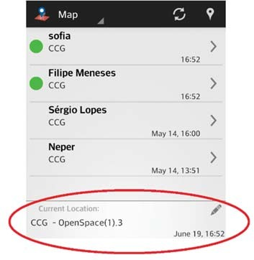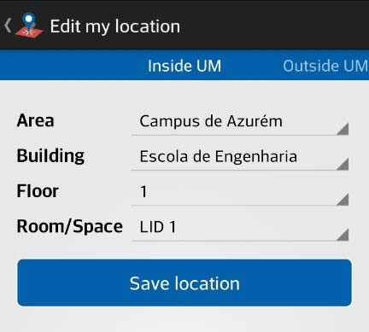

* 1. (b)

**Fig. 1.** Application developed for Android device: a) main interface showing the location of friends (top), and its user's current location (bottom); b) interface to update the user's location.

Fig. 2 presents the architecture of the implemented solution. The mobile applica- tion runs on an Android mobile device and interacts with a dedicated server. The server has two main modules: the application support module that provides the func- tionalities necessary for the positioning and for the social networking features (add friends, login/logout, send friendship request, etc.), and the radio map construction module.

The mobile application uses the mobile device Wi-Fi interface to periodically col- lect fingerprints. The Wi-Fi fingerprints are transmitted to the server application sup- port module that replies with the corresponding location. This server module acts as a gateway: it forwards the fingerprints to the positioning engine and replies with the corresponding location information.

The process of building radio maps must be done consistently and with minimum degree of reliability, i.e., whenever a user claims that he/she is at a specific location, the positioning system cannot immediately assume that information is trustable. To solve the reliability problem, we introduced a radio map construction module that saves the annotated fingerprints received from each user on a temporary database. The information stored in the temporary radio map database will also be used later to im- prove the positioning engine database if it is considered reliable, i.e., if different users provide similar fingerprints for the same place.

With the temporary radio map data it is possible to make a first attempt to recog- nize where mobile devices are located, without using the positioning engine, even before annotated fingerprints are considered reliable. If subsequent, non-annotated, fingerprints are received on the server within a short time window, then the server can

try to estimate the current user's position from the latest annotated fingerprint, instead of using the positioning engine. First, if the time difference to the latest annotated fingerprint is very short (a few seconds), then the system can assume that the user is still at the same location. Otherwise, if the fingerprints are very similar then the sys- tem can also assume that the user has not moved to a new location. Both situations are important in terms of the mobile application interface: we cannot ask the user to con- secutively provide his current location just because the fingerprints are slightly differ- ent or because we ignore the location that was provided just a few moments before.

# Place matching

In this paper we focus on the problem of detecting when two fingerprints are similar enough to be considered to represent the same place.

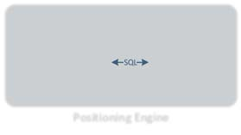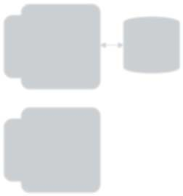

**Server**

**Mobile Device**

Application module

Mobile

application support module

Application

support database

User interface

Local

cache

Data collection

from APs

Radio map

construction module

Radio map

database

Communication protocol:

HTTP SQL

Interface C

Positioning engine

Positioning

engine database

**Positioning Engine**

Wi−Fi Interface

Interface B

Interface A

**Fig. 2.** System overview.

SQL

## Fingerprints distance

Several factors lead to different Wi-Fi fingerprints in the same place, even if two con- secutive fingerprints are created within a very short time period. The presence and movement of persons, the presence of other devices, and other factors change the environment and may reflect or attenuate the radio signals and have a large effect on the RSSI values.

A fingerprint is the list of Access Points, identified by the corresponding MAC ad- dress, that

are obser them. A

=

ved fin

{

by the radio i gerprint for a lo

, },

nterface and t cation *A* is re

,

he pres

, …

corresp ented

, {

onding RSSI by:

, }

value for

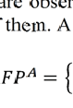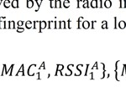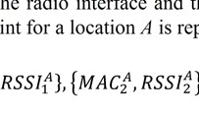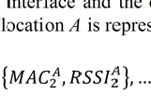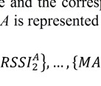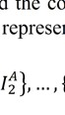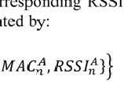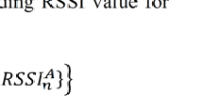

each one of

Our application periodically creates a new fingerprint. However, even in the same exact place two consecutive scans generate different fingerprints and thus the user' movements can in some circumstances be difficult to detect. For the exact same loca- tion we find different fingerprints due to the signal fluctuation and for locations geo- graphically near we find that fingerprints are different but sometimes with a consider- able degree of similarity, since some or most of the Access Points available are the same.

It is necessary to distinguish between when the user moves to a different location and when he continues in the same place. To detect the user movement it is necessary to calculate the similarity between fingerprints and decide if the difference is high enough to indicate a different place. To measure the similarity between two finger- prints we implemented a distance function (equation 1) that computes the distance between two fingerprints.

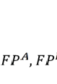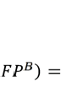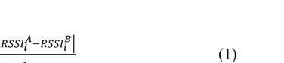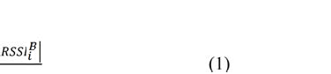

∑

The distance between two fingerprints is defined as the sum of the absolute differ- ence between the RSSI values of each Access Point divided by the total number of Access Points (*n*).

(

,

) =

(1)

The lists of Access Points contained in the two fingerprints may not be the same, even if both fingerprints are created in the exact same location. For example, one Access Point may have a very low signal level and a few instants later it may not be detected by the same Wi-Fi network card. In these cases, when an Access Point is present in only one fingerprint, the system assumes a default value for the missing RSSI parameter (*defRSSI*) and the distance is calculated by the difference between the default value and the RSSI value contained in the second fingerprint.

Other distance functions have been evaluated, including the more common Euclid- ean Distance (norm 2). Further results on this comparison are described in [8].

## Similarity level

If the distance between two fingerprints is higher than a pre-defined threshold the system concludes that the user has moved to a new location. This pre-defined thresh- old parameter defines the distance limit between two fingerprints to be considered as representing or not two distinct places.

The optimum threshold value is the one that makes the application to positively identify all the fingerprints that corresponds to a place (positively identify the lack of

movement) and that also makes the application to distinguish distinct places. A false positive occurs when the similarity between two samples collected in different rooms is below the threshold, and a false negative occurs when the similarity between two samples collected in the same room is above the threshold. If the threshold is defined to a value lower than the optimum value this will cause excessive false negatives. A threshold higher than the optimum value causes excessive false positives.

# Experiments and results

An experiment has been conducted to evaluate the proposed solution. First, 16 differ- ent rooms/halls, from 5 different buildings, have been selected across the university campus. Some of these rooms are far away from all the others (isolated), while some others have been selected to be right next to each other as is shown in Fig. 3. This selection of rooms aims to represent a variety of real-world situations ranging from small rooms to large halls, and covering a wide range of distances between pairs of spaces. In each room/hall, 8 fingerprints have been collected, 4 in each one of two different locations inside the room (typically the corners of the rooms). These two locations have been used to capture the difference in the radio environment that we know is typical even in small rooms. Larger scale evaluations, including more rooms and more locations per room will be performed in the near future. The process of collecting these was realized by a different application (uses the same fingerprints scanning module used in the main application) to get more control on the readings that were done. The 128 collected fingerprints have then been processed offline as follows.

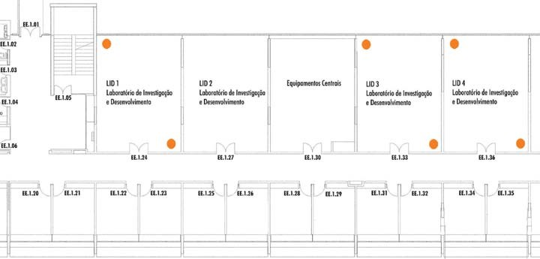

**Fig. 3.** Plan of the first floor of Engineering School with the marks (orange circles) where the fingerprints were collected. This was the most conflictual area, as can be seen in the bottom- right part of the Fig. 6, mainly because one of the walls of each room is made of glass.

Our main goal is to estimate if the most recent fingerprint collected by the mobile application has been collected in the same room as the latest annotated fingerprint. As

described in the previous section, the user is declared to be in the same room if the distance (equation 1) between the two fingerprints is below a given threshold. The pairwise distances between all the 128 fingerprints have been computed, and the number of false positives (FP) and false negatives (FN) has been computed as a func- tion of the threshold. Fig. 4 shows the computed FP and FN as a function of the simi- larity threshold for two different values of the *defRSSI* parameter.

0.20 0.20



FP

FN



FP

FN

0.15 0.15

0.10 0.10

0.05 0.05

0.00

0 5 10 15 20 25

threshold

(a)

0.00

0 5 10 15 20 25

threshold

(b)

**Fig. 4.** False positive and false negative rates: a) defRSSI = -110; b) defRSSI = -90.

The results in Fig. 4 show that, for this experiment, the rate of false negatives is always below 6% even for low values of the threshold. It also shows that the value of the *defRSSI* parameter has a significant impact on the number of false positives and false negatives. It is also shown that, as expected, the optimum value for the threshold must be a trade-off between minimizing the number of false positives and the number of false negatives.

One possible criterion for the choice of the threshold value could be to use the sum of the false positives and false negatives (total number of erroneous estimates) and to select the threshold value that minimizes this metric. However, this value for the threshold might not be the one that leads to a better user experience: if a user anno- tates a fingerprint (saying explicitly where he/she is at) and after a few seconds the system reports a different location (a case of a false negative), the user might think that the system is ignoring his/her contribution. On the other hand, if the user moves into a different place and the system keeps reporting the previously visited place (a case of a false positive), the user might think that the system exhibits a long lag on updating the position. The optimum balance between these two cases might be differ- ent for each user, and the choice of the value that maximizes the user experience for the majority of the users depends on a large-scale user study. This study is planned for the near future. While the results of this study are not available, we will use the sum of the false positives and false negatives (F) as a metric for the optimization of the place matching solution.

Given the metric just described, the optimum value for the threshold is the one that minimizes F (Fmin). However, as illustrated in Fig. 4, that value depends on the value of the *defRSSI* parameter used for computing the distances between fingerprints. Fig. 5 shows the value of the optimum threshold, and corresponding value of Fmin as a function of *defRSSI*.

The minimum value of Fmin is obtained for *defRSSI* around -109, corresponding to an optimum threshold of around 17.5. With these optimum parameters, Fmin is below 1,9% which is an acceptable value for the envisioned application.

A graphical view of the place matching performance is depicted in Fig. 6, where each green dot represents the cases where the system reports the user as still being in the same room where the previous annotated fingerprint has been collected, and the orange dots represent the cases where the system reports de user as being in a differ- ent room. The optimum case would be the one where all the distances between the 8 fingerprints collected inside each room would be below the threshold (perfect squares along the diagonal), and all other distances would be above the threshold.

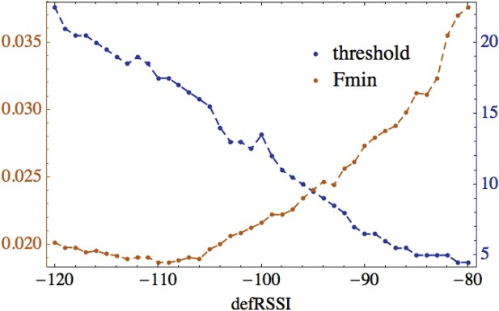

**Fig. 5.** The impact of defRSSI on the optimum value of the threshold.

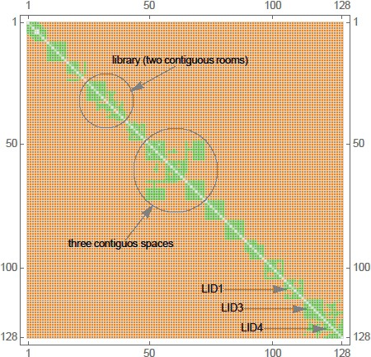

**Fig. 6.** Overall performance of the place matching solution.

Globally, the results represented in Fig. 6 show a low rate of false negatives (most squares are full green), but there are a few cases of false positives. These cases occur, as expected, for the cases of rooms that are next to each other (middle and bottom right parts of the graph).

# Related work

Anthony LaMarca, et al. [2] proposed a system called Place Lab in order to provide location information to consumers of mobile devices (such as laptops, PDAs and mo- bile phones) through listening to radio beacons emitted from Wi-Fi networks, GSM base station transmitters or Bluetooth devices. Listening to radio beacons by users allow the system to collect important data, such as Wi-Fi APs MAC address, and to estimate the user's position based on the geographical location of installed beacons transmitters. The user's position is obtained by prior knowledge of those locations, without this information the system is unable to make an estimate of the position. The Place Lab system reveals that it is possible to estimate user's locations with an aver- age accuracy of 15 to 20 meters if there is enough density of Wi-Fi beacons transmit- ters.

RADAR is a location and user's tracking system for indoor environments, devel- oped by P. Bahl and V. N. Padmanabhan [1]. This system is Wi-Fi fingerprinting- based, recording and processing RSSI values obtained of detectable APs. Subsequent- ly it combines experimental measurements with signal propagation models to estimate user's locations and later allow the usage of these services in location-based applica- tions. To estimate the user's location, the system needs to go through two phases: calibration phase (offline) and positioning phase (online). In the calibration phase, the system collects data (such as reading time, APs RSSI values and Cartesian coordi- nates of the device) of several places marked in the building map. Afterwards, in the positioning phase, the system continues to collect signal information but this time in real time. The collected data are compared with the offline ones and is applied a tri- angulation algorithm to estimate user's position. RADAR reveals that it is possible to estimate the user's location with an average accuracy of 2 to 3 meters.

Molé [3] is also a mobile location engine based on Wi-Fi networks. Molé distin- guished himself by introducing new techniques to, among others, associate a name to a fingerprint and distinguish neighbouring places. It also includes a motion detector (based on accelerometer) to reduce the frequency of readings and implements a scala- ble cloud-based distribution system of fingerprints. Molé organizes places' names hierarchically with five levels: country, region, city, area and a specific location name. This approach allows that a building data may be pre-loaded onto the mobile device through a compact data structure, enabling it to distinguish potential places with similar fingerprints. The location algorithm introduced by Molé, Maximum Overlap (MAO), estimates the place by selecting the fingerprint that is more likely similar to the user's fingerprint using a similarity function. Some tests to positioning algorithms, motion detection and use of fingerprints similarity are presented in [3]. The results indicate an increase of 10% precision with MAO location algorithm com-

pared to state of the art at the time, and also show that the use of the motion detector can significantly reduce the delay of updating and eliminating "false readings", result- ing in a better estimate of the position.

The work presented in this paper is closely related to the Molé system in that it also depends on explicit users' input to build and maintain the radio map. It is different from Molé since we are combining an organic approach to a more conventional ap- proach based on offline calibration of some spaces. Our system is not yet complete and, therefore, a direct comparison with the performance of Molé is not yet possible. Other authors also explored collaborative approaches for creating radio maps [6, 7] and, again, a direct comparison with their results still depends on the conclusion of our system.

# Conclusion

Our goal is to implement a large-scale indoor positioning system based on Wi-Fi fin- gerprints. Since radio maps are almost impossible to be built manually in very large facilities we decided to explore a collaborative approach around place-based social networks.

In this paper we presented briefly an application for Android mobile devices that collects Wi-Fi fingerprints and requests the user collaboration to identify the location where a fingerprint is created. It is important to be able to detect when two finger- prints are similar and thus correspond to the same place. We have made several tests with a set of fingerprints collected in different locations inside our campus and we were able to achieve a low rate of false negatives and a few cases of false positives (in rooms that are located next to each other).

In the near future we will conduct some tests with real users. We intend to provide the same application configured with different parameters to different users to under- stand if the different level of false positives and false negatives influences the user perception of quality and reliability. Further work is also being done on the integra- tion of the annotated fingerprints on the running radio map used by the positioning engine. The impact of using different Android devices to collect the fingerprints should also be evaluated.

**Acknowledgements.** This work has been supported by FCT – Fundação para a Ciên- cia e Tecnologia within the Project Scope: Pest OE/EEI/UI0319/2014.

# References

1. Bahl, P. and Padmanabhan, V.N.: RADAR: an in-building RF-based user location and tracking system. In: IEEE Conference on Computer Communications (INFOCOM'00), pp. 775-784, March 2000.
2. Anthony LaMarca, et al.: Place Lab: Device Positioning Using Radio Beacons in the Wild. In: Proceedings of the third International Conference on Pervasive Computing 2005, Munich, Germany, 8-13, May, 2005.
3. Ledlie, J., Park, J., Curtis, D., Cavalcante, A., Camara, L., Costa, A. and Vieira, R.: Molé: a Scalable, User-Generated WiFi Positioning Engine. In: Indoor Positioning and Indoor Navigation (IPIN), 2011 International Conference on, pp. 1-10, 2011.
4. Xiao, J., Wu, K., Yi, Y. and Ni, L. M.: Fine-Grained Indoor Fingerprinting System. In: Computer Communications and Networks (ICCCN), 2012 21st International Conference on, 2012, pp. 1-7.
5. Monteiro, R. and Moreira, A.: Mapeamento Automático de Redes WiFi com base em As- sinaturas Rádio. In: CRC'2010 - 10ª Conferência sobre Redes de Computadores. pp. 167- 172, Universidade do Minho, Braga, Portugal, 2010.
6. Kim, Y., Chon, Y., Cha, H., Li, M. and Park, S.: Scalable and Consistent Radio Map Man- agement Scheme for Participatory Sensing-based Wi-Fi Fingerprinting.
7. Kim, Y., Chon, Y. and Cha, H.: Smatphone-based collaborative and autonomous radio fin- gerprinting. In: Systems, Man, and Cybermetics, Part C: Applications and Reviews, IEEE Transactions on, vol. 42, pp. 122-122, 2012.
8. Marques, N., Meneses, F., Moreira, A.: Combining similarity functions and majority rules for multi-building, multi-floor, WiFi Positioning. In: Proceedings of the 2012 International Conference on Indoor Positioning and Indoor Navigation (IPIN), Sydney, Australia, pp.1- 9, 13-15 November, ISBN 978-1-4673-1954-6, 2012.